1. Convert the following while loop to a do-while loop: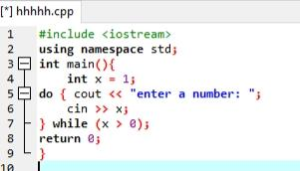
2. Use a do while loop to make a simple calculator for two numbers. Insert buttons for it to ask again and for termination.

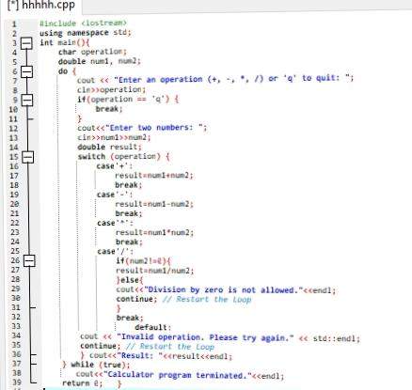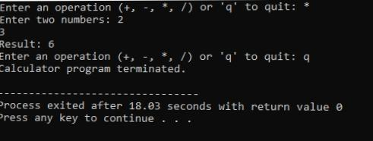

1. Write programs with while or do while loops that compute:
2. The sum of all even numbers between 2 and 100 (inclusive).

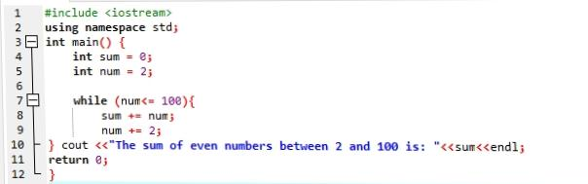

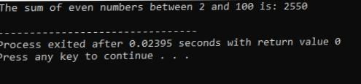

1. 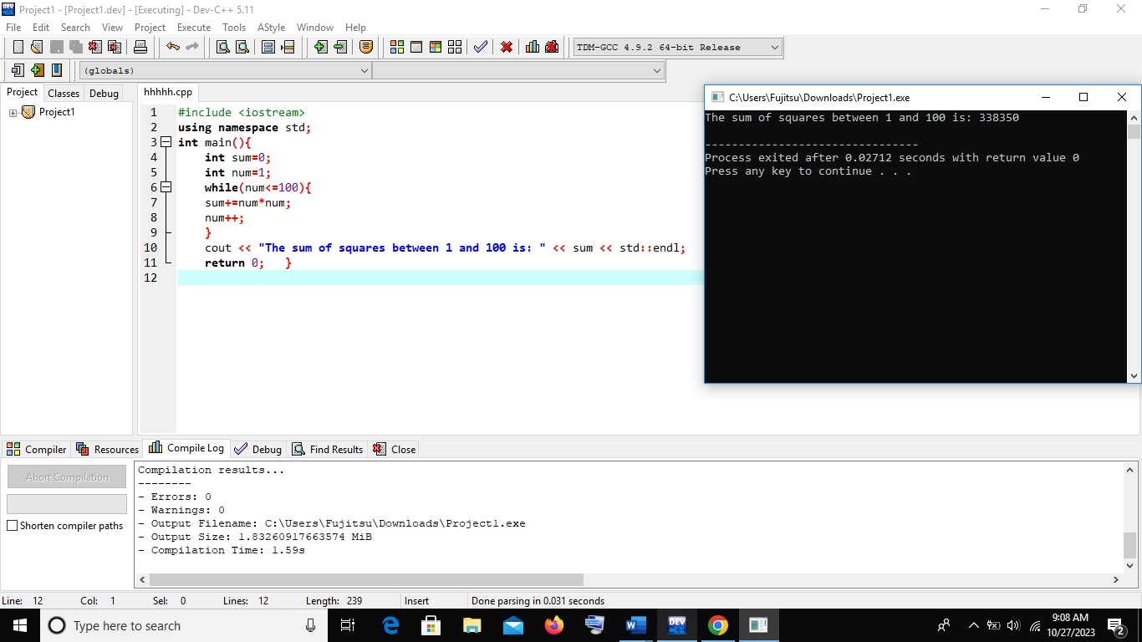The sum of all squares between 1 and 100 (inclusive).
2. Write programs with while or do while loops that compute:
   1. 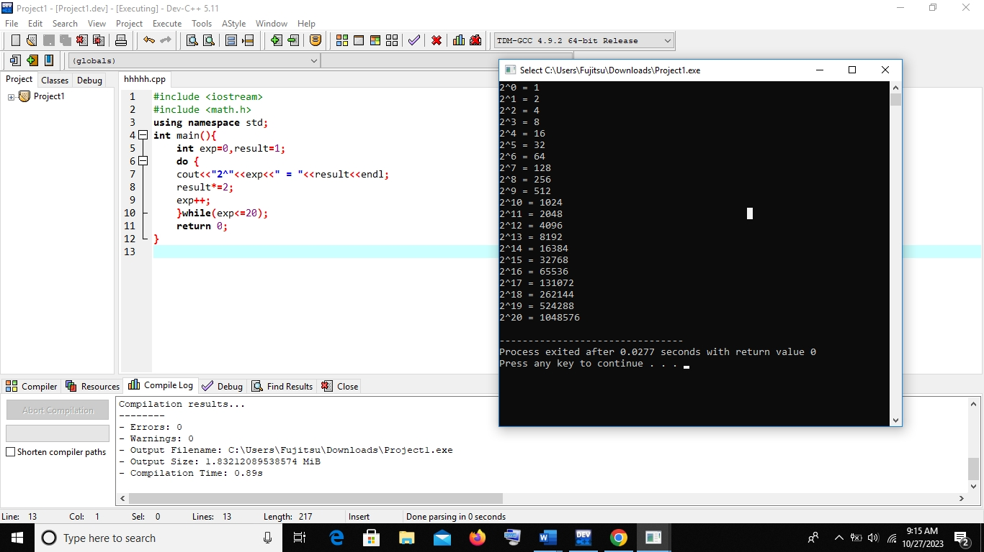All powers of 2 from 2^0 to 2^20.
   2. The sum of all odd numbers between a and b (inclusive), where a and b are inputs.

